Week 2 — Creating Financial Forecasts
Forecasting India's Bank Non-Performing Loan Ratio
World Bank World Development Indicators | Indicator: FB.AST.NPER.ZS

1. Executive Summary
This report develops a basic financial forecast using the same financial-indicator framework established in Week 1. The selected indicator is India's bank non-performing loans (NPL) to total gross loans ratio, measured as a percentage. NPLs are a useful financial-risk indicator because they describe the share of a bank's loan portfolio that is impaired or at risk of default. The World Bank identifies FB.AST.NPER.ZS as a measure of banking-system asset quality and potential credit risk.
The forecasting exercise uses annual observations from 2011 through 2023 and applies a three-year simple moving-average model. The method was selected because it is transparent, easy to reproduce, appropriate for a small annual dataset, and does not require strong assumptions about the underlying functional form of the series. Forecasts are generated recursively for 2024–2026. The resulting baseline forecasts are 4.33%, 3.61%, and 3.21%, respectively.
A rolling one-step backtest was also performed over the historical sample. The model produced a mean absolute error of approximately 2.42 percentage points and a root mean squared error of approximately 2.80 percentage points. These errors demonstrate that the simple model has limited precision and should be treated as a baseline rather than a high-confidence predictive model.

2. Objective
The objective is to extend the Week 1 exploratory analysis into a basic time-series forecasting exercise. Specifically, the report aims to select a relevant financial indicator, justify a simple forecasting model, implement the model, generate future estimates, evaluate historical forecast performance, and discuss the meaning and limitations of the results.

3. Indicator Selection
The selected indicator is Bank non-performing loans to total gross loans (%), World Bank code FB.AST.NPER.ZS. The indicator measures the proportion of a deposit taker's loan portfolio that is impaired or at risk of default. It is directly related to asset quality and potential credit risk, making it a natural candidate for a financial forecast.
India was selected because it was included in the Week 1 country sample and therefore provides continuity between the two weeks. Unlike the Week 1 cross-sectional snapshot, forecasting requires a historical time series for one country and one indicator. The historical series used here contains annual observations for 2011–2023.

4. Data Source and Preparation
The primary data source is the World Bank World Development Indicators. The World Bank's India indicator page identifies the NPL series as covering 2005–2023, while the Week 1 project retained India's latest observation for the cross-country comparison. For Week 2, the historical observations from 2011–2023 were used so that the indicator could be modeled over time.
No values were interpolated for missing historical years. The selected 2011–2023 annual sequence is used directly in the forecasting model. The 2023 value is approximately 1.7%, consistent with the Week 1 analytical dataset, which reported approximately 1.72%. Values are rounded to one decimal place in the forecasting dataset for consistency with the published historical series used in the model.
Year | NPL ratio (%)
2011 | 2.7
2012 | 3.4
2013 | 4.0
2014 | 4.4
2015 | 5.9
2016 | 9.2
2017 | 10.0
2018 | 9.5
2019 | 9.2
2020 | 7.9
2021 | 6.5
2022 | 4.8
2023 | 1.7

5. Model Design and Justification
A three-year simple moving average (SMA) was selected as the forecasting model. The model calculates the average of the three most recent observations and uses that average as the next forecast. For future years, the process is recursive: once a forecast is produced, it becomes part of the history used to calculate the following forecast.
The model was chosen for four reasons. First, it is transparent and easy to explain. Second, it reduces the influence of one-year fluctuations, which is useful for a financial-risk indicator that can be volatile. Third, the historical dataset is relatively small, so a complex model could create a false impression of precision. Fourth, the method can be reproduced easily in Python and checked manually.
The model can be expressed as: Forecast(t) = [Y(t−1) + Y(t−2) + Y(t−3)] / 3.

6. Implementation
The model was implemented in Python using Pandas and NumPy. The code stores the historical observations in a DataFrame, calculates the rolling three-year average, produces recursive forecasts for 2024–2026, and calculates backtest error metrics. A separate CSV file contains both the historical observations and forecast values so that the results can be inspected independently of the code.
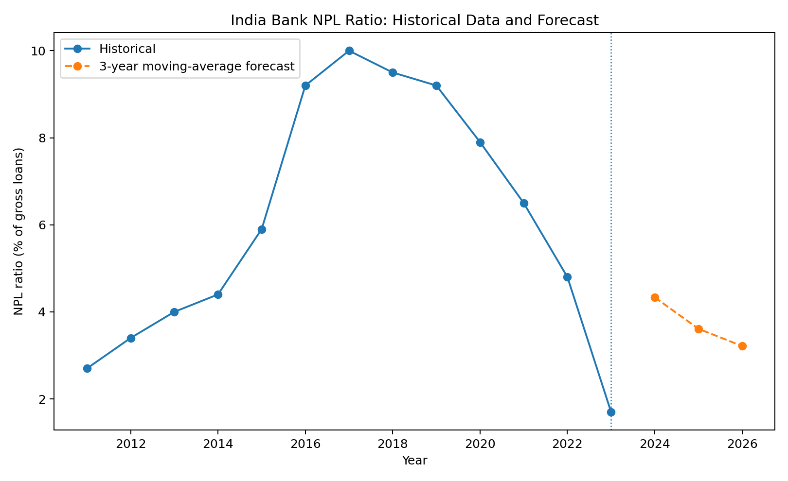
Figure 1. India's bank NPL ratio, historical observations and three-year moving-average forecast.

7. Forecast Results
Forecast year | Forecast NPL ratio (%)
2024 | 4.33%
2025 | 3.61%
2026 | 3.21%
The model produces a baseline forecast of 4.33% for 2024, 3.61% for 2025, and 3.21% for 2026. The forecast path declines gradually rather than continuing the full magnitude of the sharp decline observed between 2022 and 2023. This is a direct consequence of the moving-average design: recent observations receive equal weight, so the model smooths the latest movement instead of extrapolating it mechanically.

8. Model Validation
A rolling one-step backtest was used to assess the model. For each year with at least three prior observations, the model calculated a forecast using only the preceding three actual observations. The resulting errors were summarized using mean absolute error (MAE) and root mean squared error (RMSE).
Backtest MAE: 2.42 percentage points. Backtest RMSE: 2.80 percentage points. The error size is material relative to the level of the series, showing that the model should be considered a simple baseline rather than a highly precise forecasting system.
The backtest is important because it tests the model on historical information instead of judging it only from the final forecast. It also highlights why financial forecasting should be accompanied by uncertainty and model limitations.

9. Interpretation
The forecast indicates a gradual normalization of the NPL ratio after the elevated levels observed during the middle of the historical sample. However, the model does not claim that India's actual future NPL ratio will follow this exact path. The moving average is intentionally conservative in how it extrapolates the latest observation and does not incorporate explanatory variables such as GDP growth, interest rates, unemployment, credit growth, provisioning, or regulatory changes.
The main analytical value of the forecast is therefore as a baseline scenario. It provides a simple reference path against which more advanced models could be compared. A future version could incorporate macroeconomic variables, use exponential smoothing or ARIMA-type methods, and generate prediction intervals.

10. Limitations
- The model uses a small annual sample of 2011–2023.
- A moving average is a univariate model and does not explain why NPLs change.
- The model does not explicitly capture economic shocks, banking regulation, provisioning changes, credit growth, or changes in reporting practices.
- Forecast errors are relatively large compared with the level of the indicator.
- Forecasts should be interpreted as a baseline scenario, not as investment or policy predictions.
- The forecast origin is 2023 so that the exercise remains consistent with the historical information used in the Week 1 dataset; subsequently published observations should not be treated as if they were known when the model was estimated.

11. Conclusion
This Week 2 exercise extends the Week 1 financial-data analysis into forecasting. India's bank NPL ratio was selected because it is a meaningful banking-system risk indicator and was already part of the Week 1 dataset. A three-year simple moving average was implemented because it is transparent, reproducible, and suitable as a baseline for a small annual dataset. The model generates a declining forecast path for 2024–2026, but historical backtesting shows that the forecast has meaningful error. The main conclusion is therefore not that the exact forecast values are certain, but that a simple quantitative baseline can be built and evaluated using the same financial dataset framework. More advanced forecasting would require a longer and more consistently updated time series and potentially additional explanatory variables.

12. Sources
World Bank. World Development Indicators. Bank nonperforming loans to total gross loans (%), indicator FB.AST.NPER.ZS.
World Bank indicator page: https://data.worldbank.org/indicator/FB.AST.NPER.ZS?locations=IN
World Bank metadata: https://databank.worldbank.org/metadataglossary/all/series/viewall?search=industry+value+added%3B
Historical values used in the 2011–2023 modeling series were cross-checked against public historical reproductions of the World Bank series. The project treats the World Bank WDI series as the primary source.

